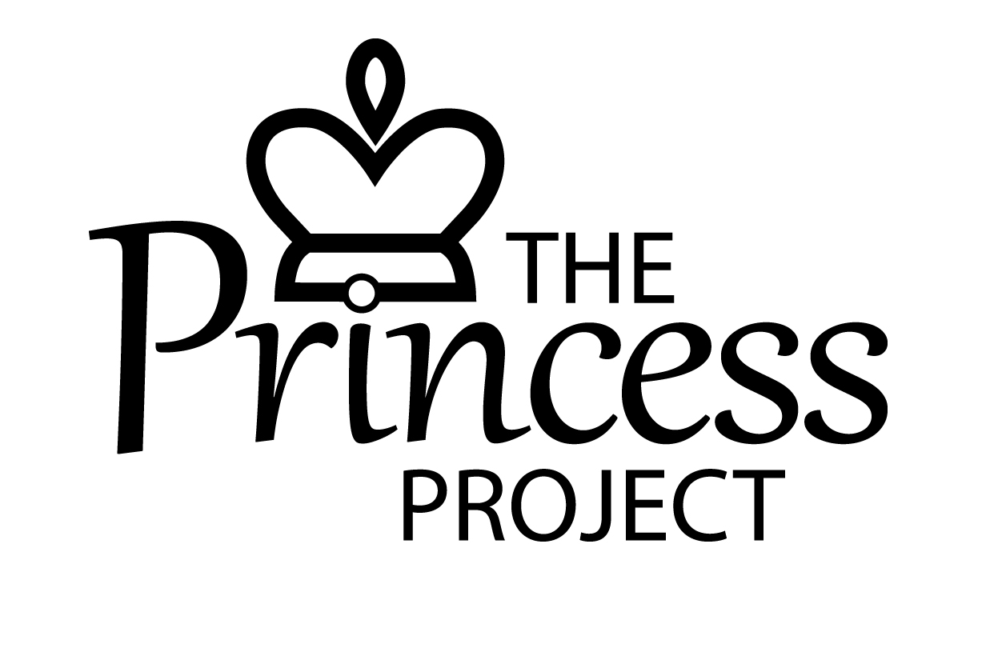
REFERRAL FORM for families requiring support

Date of Referral:_________________ Referred by:_________________________________________________

Referrer contact number/email:_______________________________________Position:________________________________

Reason for Referral:__________________________________________________________________________

__________________________________________________________________________________________
Client Details
Name:_____________________________________________________________________________________
Address:___________________________________________________________________________________
__________________________________________________________________________________________
Tel:_____________________________________ Ages of children:____________________________________
What essentials do you need? (Please tick all that apply)
Nappies Size(s) needed____________________________
Formula Brand/stage needed________________________
Children’s Clothing Size(s) needed_____________________________
Toys Age/type needed___________________________
Other baby/toddler items Please give details___________________________

Please note that requests for items does not guarantee that we are able to supply them. We will do our best to meet all the needs we can with the resources we have available. Toys, clothing and other baby/toddler items are all second-hand donations and are provided to you free of charge, in good faith. The Princess Project provides no guarantees for these items and they are accepted and used at your own risk. All food, formula and toiletries are new and unopened.
Please return this form to support@princessproject.co.uk, or screenshot it and send via text or whatsapp to 07851 196770. Please do contact us if you have any questions or queries- we are here to help.

