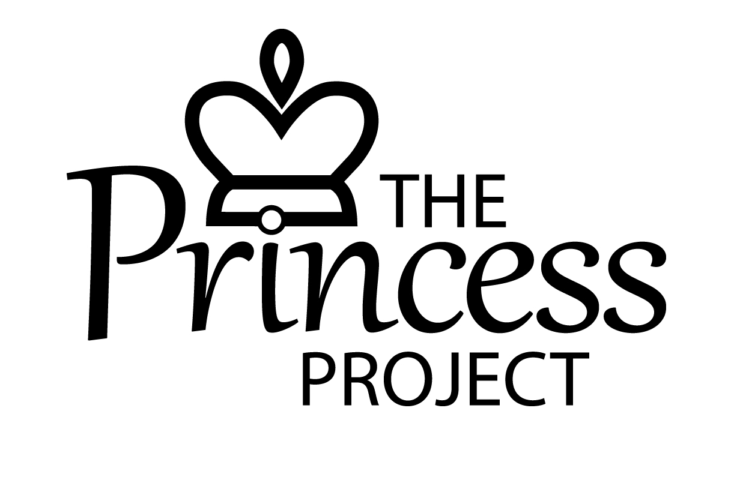
REGISTRATION FORM for CAP Money, Parentalk and Shine Courses

Date: _________________

Name: ____________________________________________________________________________________
Address: __________________________________________________________________________________
__________________________________________________________________________________________
Tel:_____________________________________ Ages of children:____________________________________

Which course are you interested in? (Please tick all that apply)
CAP Money (money management and budgeting)
Parentalk (parenting children aged 0-11)
Shine (for women- exploring your worth and purpose, building self-esteem and confidence)

Would you need to bring your child(ren) with you, if attending a course during the day? Yes/No

Please return this form to support@princessproject.co.uk, or screenshot it and send via text or whatsapp to 07851 196770. We will be in touch with details of upcoming courses, and to answer any questions you might have.

