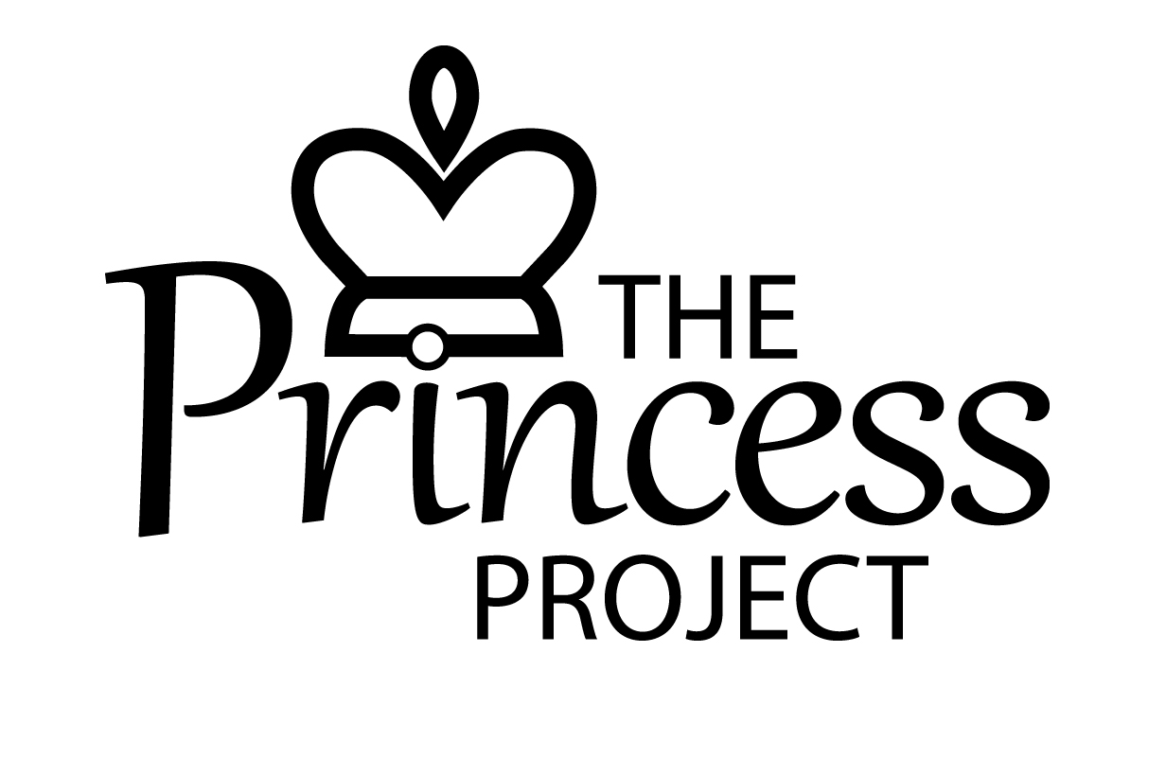
VOLUNTEER APPLICATION FORM

PERSONAL DETAILS

Surname: ………………………………………………………………………………………….

First Names: ………………………………………………………………………………………….

Address: ………………………………………………………………………………………....

…………………………………………..Post Code: ……………………………….

Email: ………………………………………………………………………………………….

Telephone Numbers

Home: ……….…………………... Work:……………………… Mobile: ……..……………………….

Are you a parent/ do you have parental responsibilities yourself? Y/N

Age(s) of children: ……………………………

Are you currently employed? Y/N If yes please state job title and role: ……………………………….

Do you have a driving license? Y/N Do you have use of a vehicle? Y/N

CHURCH DETAILS (if applicable)

Church: …………………………………………………………………………

Minister’s Name: …………………………………………………………………………

Main Church Contact: …………………………………………………………………………

Address: ………………………………………………………………………….

…………………………………………………………………………………Post Code: …………………..

Telephone No. …………………………………………………………………….

Email Address: …………………………………………………………………….

Princess Project Application Continued
WHICH ROLE ARE YOU INTERESTED IN?

Mum2Mum Other (please state): ……………………………………

Hub general team ……………………………………………………………..
Hub Ministry team

Courses Team

Fundraising/events

Logistics*

* e.g. Totcycle collections/deliveries/sorting

Please indicate how much time you have available (eg 2 hours per week/ 2 hours per fortnight/ 2 hours every month)

……………………………………………………………………………………………………………………..

Why would you like to be involved in the project?

………………………………………………………………………………………………………………………

………………………………………………………………………………………………………………………

………………………………………………………………………………………………………………………

What relevant skills, qualities and experience do you feel you could bring to the role you are applying for?

………………………………………………………………………………………………………………………

………………………………………………………………………………………………………………………

………………………………………………………………………………………………………………………

What challenges do you think this role might present for you?

………………………………………………………………………………………………………………………

………………………………………………………………………………………………………………………

………………………………………………………………………………………………………………………

What are your hobbies/interests?

………………………………………………………………………………………………………………………

………………………………………………………………………………………………………………………

Princess Project Application Continued
YOUR CHRISTIAN JOURNEY (MUM2MUM BEFRIENDERS/HUB MINISTRY TEAM ONLY)

Briefly tell us about your Christian journey- how you came to faith, significant moments, and how your faith impacts your daily life

………………………………………………………………………………………………………………………

………………………………………………………………………………………………………………………

………………………………………………………………………………………………………………………

………………………………………………………………………………………………………………………

………………………………………………………………………………………………………………………

………………………………………………………………………………………………………………………

………………………………………………………………………………………………………………………

………………………………………………………………………………………………………………………

………………………………………………………………………………………………………………………

………………………………………………………………………………………………………………………

Are you involved in any other form of ministry in your church, or in any other voluntary work?
If yes, please state what this involves:

………………………………………………………………………………………………………………………

………………………………………………………………………………………………………………………

………………………………………………………………………………………………………………………

OTHER MATTERS

Are there any reasonable adjustments that we as an organisation may need to make in order for you to be able to participate in the project? Yes/No

If yes, please describe.

………………………………………………………………………………………………………………………

………………………………………………………………………………………………………………………

………………………………………………………………………………………………………………………

Princess Project Application Continued
Rehabilitation of Offenders Act 1974

In this section you are asked about previous convictions. Due to the nature of the project, any roles involving front-line work with vulnerable mums (Mum2Mum befrienders, Course team, Hub team) are exempt from the provisions of the Rehabilitation of Offenders Act 1974. You are therefore required to disclose all previous convictions including any that would have been spent under the Act. Non-exempt roles (admin/logistics) only require disclosure of any unspent convictions.

Previous convictions will not necessarily exclude you from being accepted as part of the project (copies of our policy on positive disclosures are available on request). However, failure to disclose information relating to criminal convictions where you are obliged to do so may disqualify your application.

Have you ever been convicted of a criminal offence? Y/N

If yes, please specify date and nature of conviction, court and sentence imposed.

………………………………………………………………………………………………………………………

………………………………………………………………………………………………………………………

REFERENCES

Two references are required. If applying to be a befriender/Hub ministry team member, one must be from your church leader (or small group leader etc if applicable). Please state their name and address:

Reference 1 | Reference 2
Name: ……………………………………… | Name: …………………………………………
Relationship to you: ………………………………… | Relationship to you: …………………………………
Address: ……………………………………… | Address: ………………………………………...
………………………………………… | …………………………………………
Tel: ………………………………………… | Tel: …………………………………………
Email: ………………………………………… | Email: …………………………………………
DECLARATION
I declare the information given on this form is correct.

Signed: …………………………………………………………. Date: ………………………………

All information supplied is private and confidential.
Please return this form directly to Emma Tanner at The Princess Project.
The Princess Project Tel: 01622 230713
Maidstone Community Support Centre Email: emma.tanner@princessproject.co.uk
39 – 48 Marsham Street
Maidstone www.princessproject.co.uk
Kent
ME14 1HH

